Exercise 1
function [y, n] = conv_seq(x1, x2, n1, n2)
y = conv(x1, x2);
n_start = n1(1) + n2(1);
n_end = n1(end) + n2(end);
n = n_start:n_end;
stem(n, y);
title('Linear Convolution Result');
end

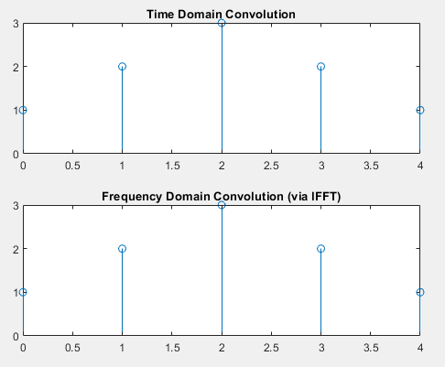
Exercise 2
x = [1 1 1];
n = 0:2;
y = conv(x, x);
N = length(y);
X = fft(x, N);
H = fft(x, N);
Y_freq = X .* H;
y_ifft = ifft(Y_freq);
subplot(2,1,1);
stem(0:N-1, y);
title('Time Domain Convolution');

subplot(2,1,2);
stem(0:N-1, real(y_ifft));
title('Frequency Domain Convolution (via IFFT)');

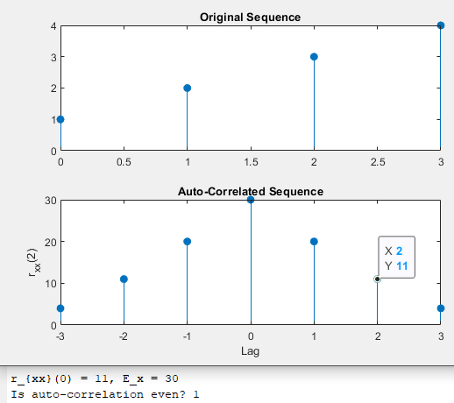

Exercise 3
x = [1 2 3 4];
rxx = xcorr(x);
lags = -length(x)+1:length(x)-1;
subplot(2,1,1);
stem(0:length(x)-1, x, 'filled');
title('Original Sequence');
subplot(2,1,2);
stem(lags, rxx, 'filled');
title('Auto-Correlated Sequence');
xlabel('Lag');
ylabel('r_{xx}(2)');
rxx_zero = rxx(lags == 2);
E_x = sum(x.^2);
fprintf('r_{xx}(0) = %d, E_x = %d\n', rxx_zero, E_x);
fprintf('Is auto-correlation even? %d\n', isequal(rxx, fliplr(rxx)));
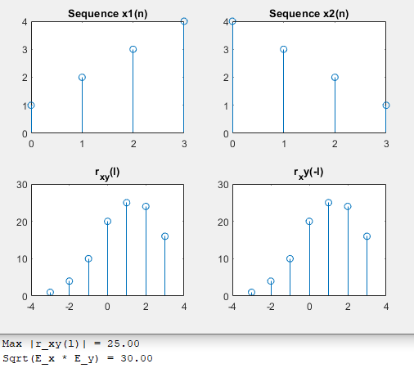
Exercise 4
x1 = [1 2 3 4];
x2 = [4 3 2 1];
rxy = xcorr(x1, x2);
lags = -(length(x1)-1):(length(x1)-1);
subplot(2,2,1);
stem(0:length(x1)-1, x1);
title('Sequence x1(n)');
subplot(2,2,2);
stem(0:length(x2)-1, x2);
title('Sequence x2(n)');
subplot(2,2,3);
stem(lags, rxy);
title('r_{xy}(l)');
ryx = xcorr(x2, x1);
subplot(2,2,4);
stem(lags,fliplr(ryx));
title('r_xy(-l)');
Ex = sum(x1.^2);
Ey = sum(x2.^2);
rxx0 = sum(x1.^2);
ryy0 = sum(x2.^2);
max_rxy = max(abs(rxy));
bound = sqrt(rxx0 * ryy0);
fprintf('Max |r_xy(l)| = %.2f\n', max_rxy);
fprintf('Sqrt(E_x * E_y) = %.2f\n', bound);
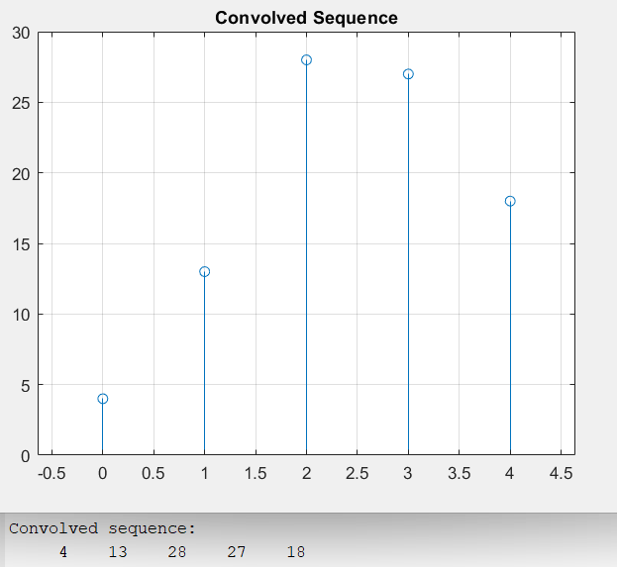
Post Lab
x = [1 2 3];
h = [4 5 6];
Lx = length(x);
Lh = length(h);
Ly = Lx + Lh - 1;
x_pad = [x, zeros(1, Ly - Lx)];
h_pad = [h, zeros(1, Ly - Lh)];
y = zeros(1, Ly);

for n = 1:Ly
for k = 1:n
y(n) = y(n) + x_pad(k) * h_pad(n - k + 1);
end
end

disp('Convolved sequence:');
disp(y);

stem(0:Ly-1, y);
title('Convolved Sequence');
grid on;

